 I Year I Semester
B Tech (Hons.) CSE (Artificial Intelligence & Data Science)
Coding & Decoding Problem Solving
Course code: 25CSE101
LAB RECORD
Name of the student: D. Bhaskar reddy
Roll No.: 25rbaid0009
Department: CSE(AI&DS)

 | Number even or odd
2 | Checking a number positive, negative, zero
3 | Largest among 3 numbers
4 | Checking for a prime number
5 | Finding factorial of a number
6 | Checking number is a palindrome
7 | String palindrome checker
8 | Printing Fibonacci series up to N terms
9 | Sum of digits of a number
10 | Counting vowels and consonants in a string
11 | Reversing a string
12 | Occurrence of each char in string
13 | Simple calculator using conditional statements
14 | Menu-driven calculator using a loop
15 | Printing multiplication table using loops
16 | Printing different patterns using loops
17 | Function which takes user name and greet
18 | Function that accepts two numbers and prints a greeting message
19 | Recursive function to find factorial of a number
20 | Lambda function to check number is even
21 | Calculate factorial using recursion with input validation
22 | Library book management system
23 | Calculator using modular programming
24 | Modular programming and reusable functions code
25 | Modular programming project
26 | User registration system

Program 01:
Q. Write a Python program to check whether a given number is even or odd.
Algorithm
- Start
- Read an integer number n
- If n % 2 == 0
  - Display "The number is Even"
- Else
  - Display "The number is Odd"
- Stop
working code:
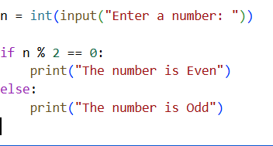
Output:

Program 02:
Q. write a python program to check whether the number is positive, negative, or zero.
Algorithm
- Start
- Read number n
- If n > 0, print Positive
- Else if n < 0, print Negative
- Else print Zero
- Stop
WORKING CODE:
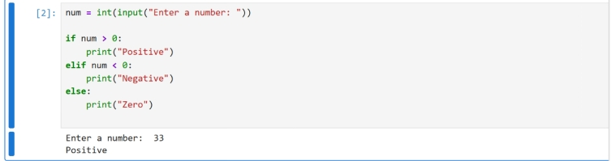
Program 03:
Q Write a python program to find largest number among three numbers.
Algorithm
1. Start
2. Read numbers a, b, c
3. Compare all three
4. Print the largest number
5. Stop
WORKING CODE:
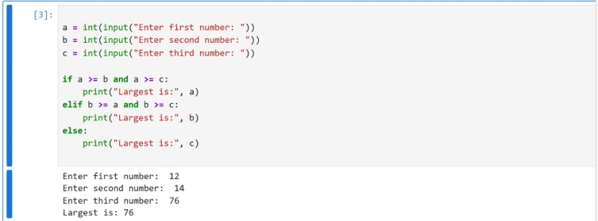
Program 04:
Q Write a python program to check whether the number entered is prime or not.
Algorithm
- Start
- Read number n
- If n ≤ 1, not prime
- Check divisibility from 2 to n-1
- If divisible, not prime
- Else prime
- Stop
WORKING CODE:
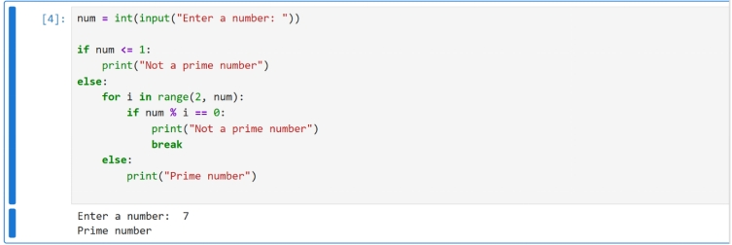
Program 05:
Q Write a python program to find factorial of a number
Algorithm
1. Start
2. Read number n
3. Set fact = 1
4.Multiply fact from 1 to n
5. Print factorial
6. Stop
WORKING CODE:
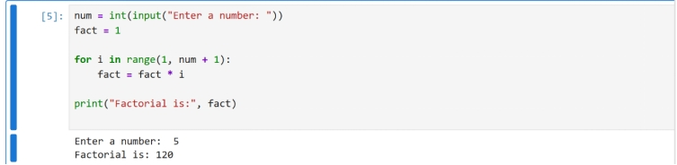
Program 06:
Q Write a python program to check whether a num entered is palindrome.
Algorithm
- Start
- Read number n
- Reverse the number
- Compare reversed number with original
- Print result
- Stop
WORKING CODE:
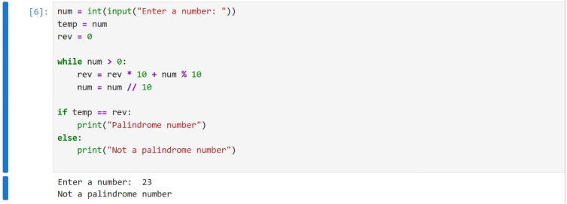
Program 07:
Q write a python program to check whether an entered string is palindrome or not
Algorithm
- Start
- Read string s
- Reverse the string
- Compare original and reversed string
- Print result
- Stop
WORKING CODE:
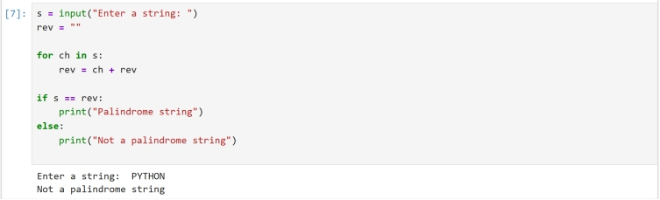
Program 08:
Q Write a Python program to print the Fibonacci series up to N terms.
Algorithm
- Start
- Read number of terms n
- Initialize a = 0, b = 1
- Print a and b
- Generate next terms
- Stop
WORKING CODE:
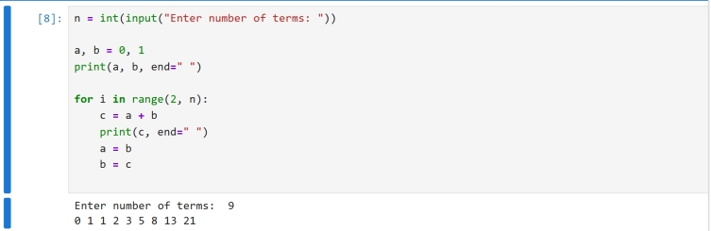
Program 09:
Q Write a Python program to find the sum of digits of a number.
Algorithm
- Start
- Read number n
- Extract each digit and add
- Print sum
- Stop
WORKING CODE:
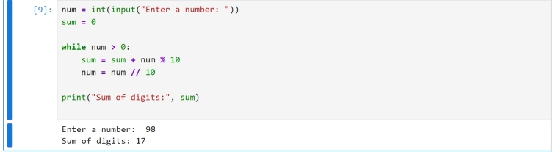
QProgram 10:
Write a python program to count vowels and consonants in a string.
Algorithm
- Start
- Read string
- Check each character
- Count vowels and consonants
- Print counts
- Stop
WORKING CODE:
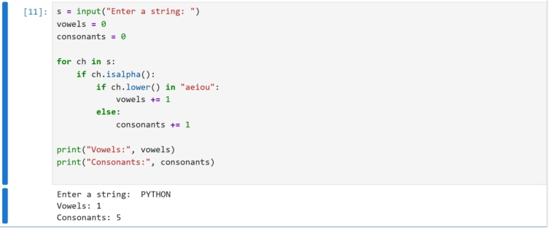
Program 11:
Algorithm
- Start
- Read string
- Reverse manually
- Print reversed string
- Stop
WORKING CODE:
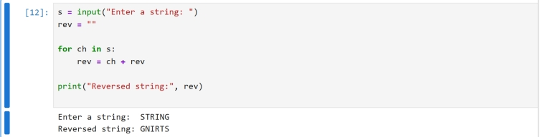
Program 12:
Algorithm
- Start
- Read string
- Count each character
- Print count
- Stop
WORKING CODE:
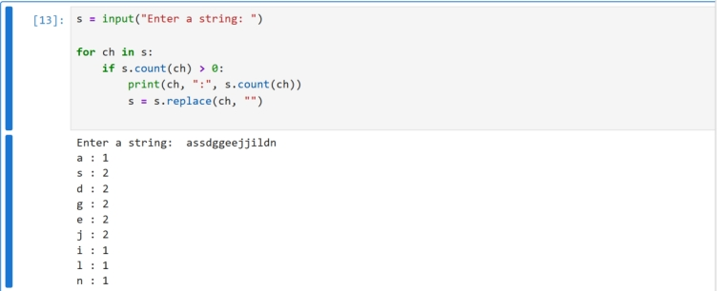
Program 13:
Q Write a python calculator program using conditional statements.
Algorithm
- Start
- Read two numbers and operator
- Perform operation
- Print result
- Stop
WORKING CODE:
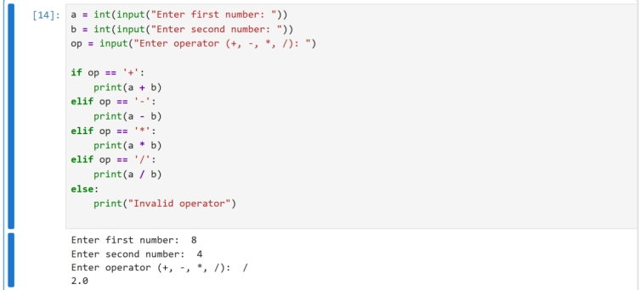
Program 14:
Q Write a python program for a Menu driven calculator using loops.
Algorithm
- Start
- Display menu
- Read choice
- Perform selected operation
- Repeat until exit
- Stop
WORKING CODE:
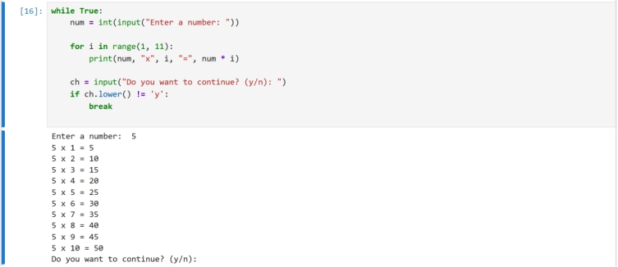
Program 16:
Algorithm:
- Start
- Initialize number of rows n
- Use outer loop for rows
- Use inner loop to print pattern
- Stop
WORKING CODE:
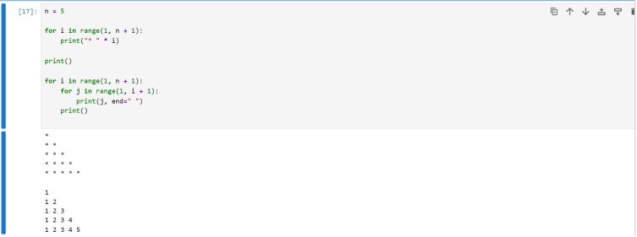
Program 17:
Q Define a python function which takes user name as input ang greet the person.
Algorithm:
- Start
- Define a function
- Read user name
- Display greeting message
- Stop
WORKING CODE:
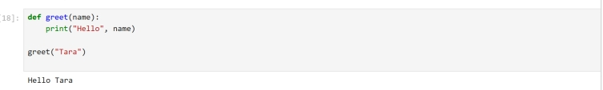
Program 18:
Q Define a function which takes two numbers as input from the user and returns the sum of those two numbers.
Algorithm:
- Start
- Define a function
- Read two numbers
- Calculate sum
- Display result
- Stop
WORKING CODE:
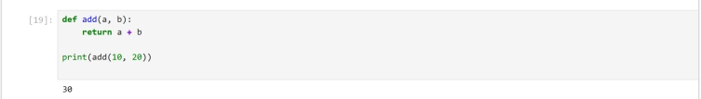
Program 19:
Q Define a recursive function to find a factorial of a number.
Algorithm:
- Start
- Define recursive function
- If n is 0 or 1, return 1
- Else return n × factorial(n−1)
- Stop
WORKING CODE:
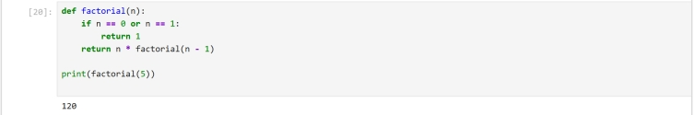
Program 20:
Q Define a lambda function to check a number is even or odd.
Algorithm:
- Start
- Define lambda function
- Check number % 2 == 0
- Display result
- Stop
WORKING CODE:
Program 21:
Q Write a python program to calculate factorial using recursion with input validation.
Algorithm:
- Start
- Read input number
- If number < 0, display error
- Else calculate factorial using recursion
- Display result
- Stop
WORKING CODE:
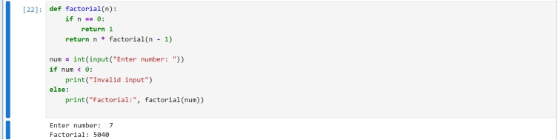

Program 22:
Q Write a python code for library book management system.
Algorithm:
- Start
- Create empty list for books
- Define add and display functions
- Perform required operations
- Stop
WORKING CODE:
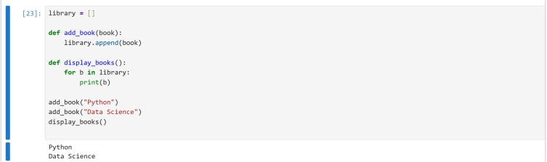
Program 23:
Q Write a Python project to build a Calculator using modular programming (separate module for operations).
Algorithm:
- Start
- Create a module with arithmetic functions
- Import the module into main program
- Read two numbers and user choice
- Perform selected operation
- Display result
- Stop

WORKING CODE:
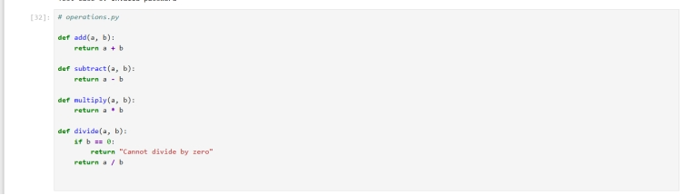
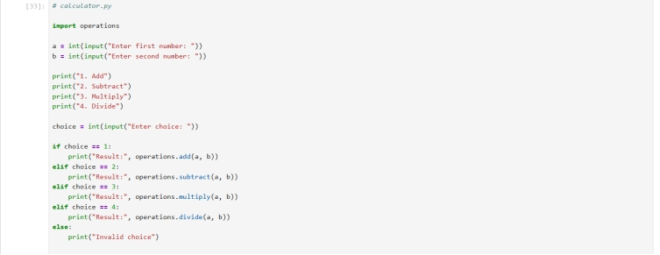
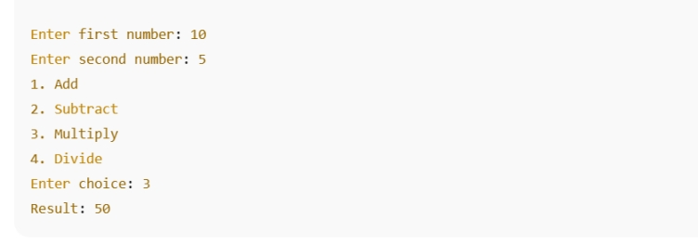

Program 24:
Q Write a Python program that applies modular programming principles and defines multiple reusable functions.
Algorithm:
- Start
- Define multiple reusable functions
- Call required functions
- Display output
- Stop
WORKING CODE:
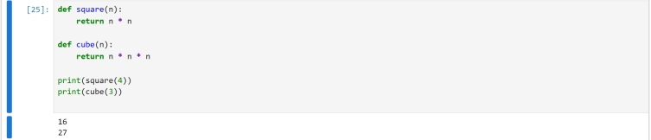

Program 25:
Q . Write a Python program using modular programming principles and demonstrate:
- Input validation
- Testing (minimum 3 test cases)
- Debugging practice with comments
Algorithm
- Start
- Define a function to validate input
- Define a function to perform calculation
- Accept input and validate it
- Display result if valid
- Test program with multiple test cases
- Stop
WORKING CODE:
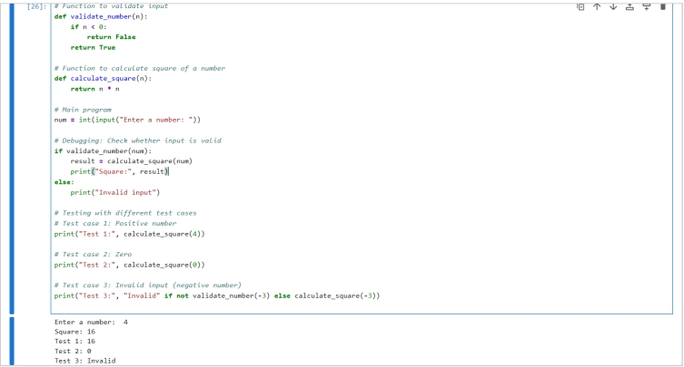

Program 26:
Q Write a Python project for a User Registration System with input validation, testing, and debugging documentation.
Algorithm
- Start
- Define a function to validate username
- Define a function to validate password
- Define a function to register user
- Accept user input
- Validate inputs
- Display registration status
- Test program with multiple test cases
- Stop
WORKING CODE:
- Define a function to validate input
- Define a function to perform calculation
- Accept input and validate it
- Display result if valid
- Test program with multiple test cases
- Stop
WORKING CODE:

Program 26:
Q Write a Python project for a User Registration System with input validation, testing, and debugging documentation.
Algorithm
- Start
- Define a function to validate username
- Define a function to validate password
- Define a function to register user
- Accept user input
- Validate inputs
- Display registration status
- Test program with multiple test cases
- Stop
WORKING CODE:
